

Colonial Shag Club dances Saturdays at the
Two Left Feet Dance Studio
(1405 Kiln Creek Parkway, 23602)
Join us Saturday nights for lessons, great music, and shag dancing at
Two Left Feet,
"Home of the Colonial Shag Club".

Saturday night, October 17th, 2026
Doors open at 6pm, dancing 6:30-9:30pm
$10 for members of any shag club (please bring membership card), $12 for all others
Soda and water provided by Two Left Feet
Snacks welcomed

DJ is Jerry Hardy
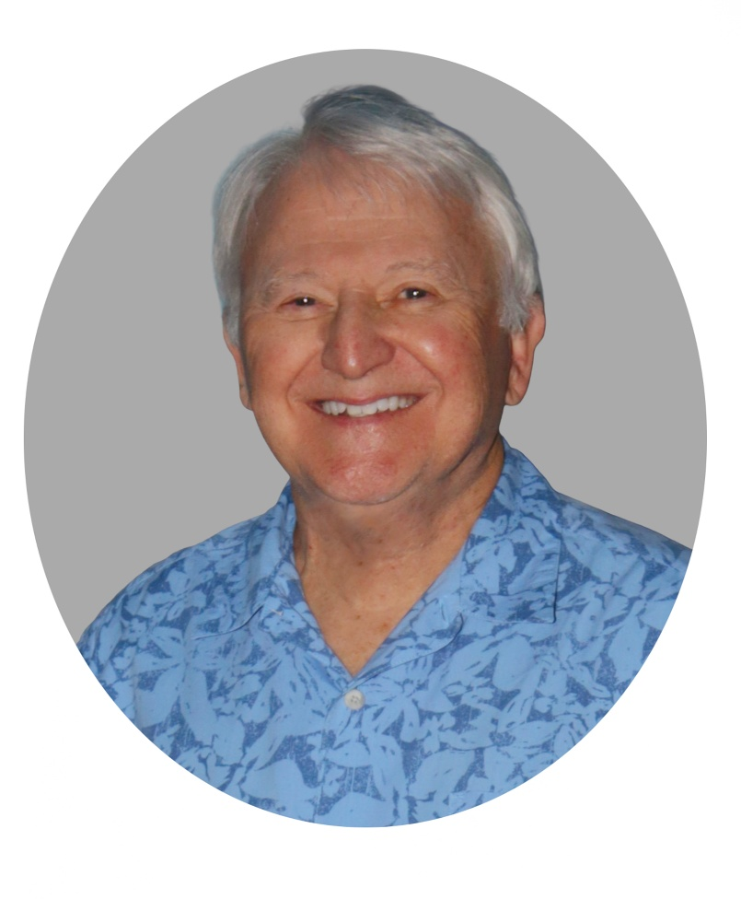
It's a Great Deal!
Where else can you get three hours of dancing, occasional food events, and bring-your-own snacks for $10!

Fall is here, So Christmas can't be far Away!
It's time to buy your Christmas Party tickets
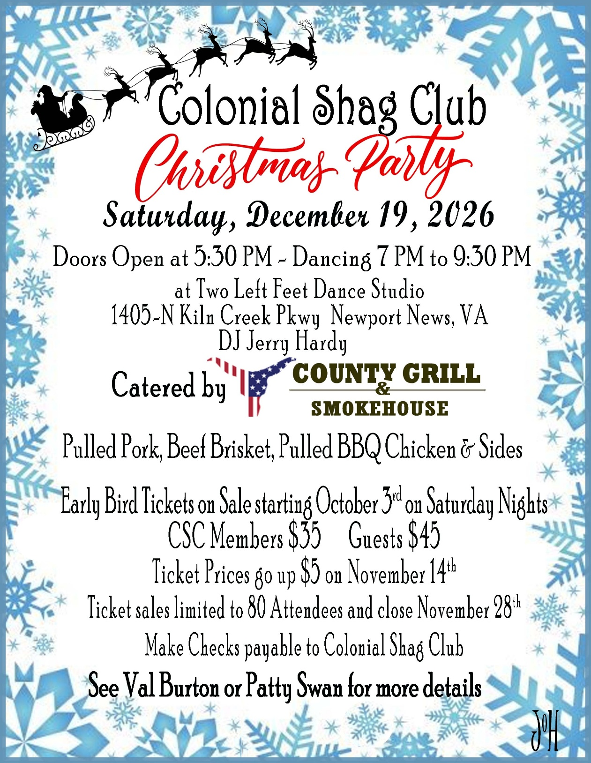

It pays to come, it pays to play, it pays to stay!
October 10th Winners!

Member Drawing
Rex Walker - Not Present
Next week's drawing will be worth $50!

Opportunities to Win
"50-50", the "Member Drawing" and the "Birthday Drawing"
50-50 = Half the pot to the winner, the other half to the club. This is an area where you can participate--coordinate with Jan to sell the 50-50 tickets.
Member Drawing = $10 to member name randomly drawn each week. If member is not present then the pot grows by $10 until there is a winner!
Birthday Drawing = Once a month the names of all members with a birthday that month are thrown in the pot. The selected member wins free membership for the following year---if they are present!
And some nights the 50-50 tickets are used for additional prizes!

Its Election Time!
This a summary of the CSC Nominating and Election
Timeline and Process
- 9/5/2026: 10 weeks prior to annual meeting, the Nominations Committee is created.
- 10/24/2026: 4 weeks prior to annual meeting at Special Membership meeting, the current Nominees are announced and any additional Nominees from the floor are permitted.
- 10/31/2026: 3 weeks prior to annual meeting and no sooner than nominees are declared, the Election Committee created.
- 11/11/2026: 10 days prior to annual meeting, Voting instructions and absentee ballot are delivered to each member who has the right to vote.
- 11/21/2026: 3rd Saturday in November, the General Election is held.
Any individual who has been a CSC member as of January 1, 2026 may submit an application to any Nominating Committee member (Mike Dyson, A.W. Jones, Delaine Milton, Al Sledd, Patty Swan).
The 2027 CSC Nomination Application form may be obtained: by downloading it from this link; from the CSC web page under the “What’s Hot” section; or from a Nominating Committee member.
Nominee's bios are due by October 25, 2026 and will be published in the CSC Newsletter.
This is your opportunity to make a difference in our Club!

CSC 2026 Calendar

October 17 - Birthday Dance
24 - Special Meeting – Present Nominees for 2027 Board of Directors
31 - Halloween Party

November 7 - CSC Board meeting
14 - Veterans Appreciation Night
21 - Birthday Dance
21 - Annual Meeting & Election of Officers for 2027 CSC Board of Directors
28 - Menchville House Check Presentation

December 12 - CSC Board meeting
19 - CSC Christmas Party/End of Year Party
19 - Birthday Dance

FREE Monday Night Shag "Practice"
Rick Tvelia (Two Left Feet) is offering open dancing for ALL SHAGGERs
on Monday nights, at 8PM
It’s a great opportunity to practice steps/moves, learn something new, ask for help, help someone else, and just dance!
No partner required!
Come out and learn! — Come out and help!

Click "here" to see current CSC Newsletter!

Be Social!
Help promote the Club by sharing CSC's Facebook and Instagram posts from your accounts.
This will help boost our visibility on these platforms and
will ensure that your friends and others like you know
'What's Happening' at CSC!

